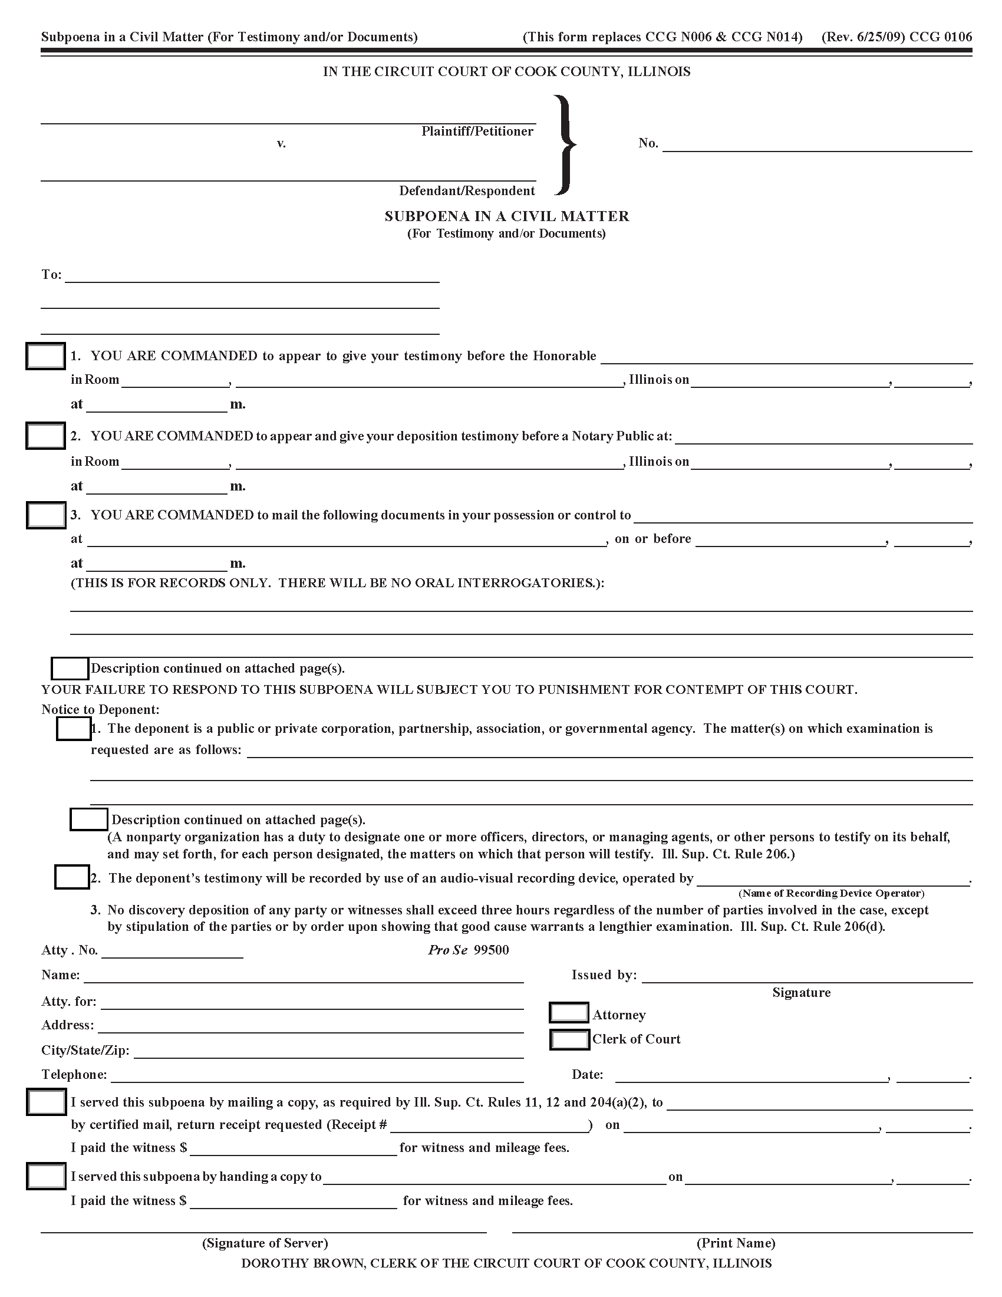
Batman
Gotham City
99-99999
University of Michigan Hospital and Health Center Release of Information Unit
2901 Hubbard Street Room 2722
Ann Arbor, MI 48109-0000
X
Axiom Requisition Copy Service

2869 Jolly Road Okemos, MI 48864
03/15/2016
5:00 p

Smith and Jones PC
123 East Main Street
Josh Sanford
Anywhere, MI 12345
(877) 886-5090
X
FROM 01/01/1979 TO PRESENT: Any and all MEDICAL RECORDS, including but not limited to patient history form(s), reports, etc. pertaining to Batman SSN: xxx-xx-5555, DOB: 01/01/1979.
John Doe
IN THE CIRCUIT COURT OF DUPAGE COUNTY, ILLINOIS

